LAB ASSIGNMENT V : HUERISTIC EVALUATION
SYSTEM EVALUATED : Emirates – Redesigned Mobile & Desktop Booking App
Groups members NAME : Ayush (and group)
**Evaluation to be done by other Group
PART I : HUERISTIC EVALUATION BASED ON NIELSEN'S 10 GENERAL PRINCIPLES FOR INTERACTION DESIGN. (0 is lowest and 5 is highest)
S.No. | Heuristic Evaluation Parameter | Mention Violation if any | Rating 0-5 (0 = worst, 5 = best) | Ways to improve
1 | User Control: Interface will allow the user to perceive that they are in control | You can go back from every screen and the menus are always there. One small thing: Home sends you to Login before you can search. | 4 | Let people search for flights first and ask them to log in later.
2 | Human Limitations: Interface will not overload the users cognitive, auditory and motor skills | Screens are clean with big, easy buttons. The Dashboard shows a lot at once (search, trip, actions, recent trips). | 4 | Hide old trips behind a 'See more' link.
3 | Accommodation: The interface will fit the way each user group works and thinks (personas) | It is made mainly for someone booking one trip. A person who flies every week gets no shortcuts. | 3 | Add a small 'Book again' button. Keep it small so the screen stays simple.
4 | Linguistic Clarity: Interface will communicate as efficiently as possible | Words are short and easy: 'Search flights', 'Check-in', 'Help'. Nothing is confusing. | 5 | Nothing to fix.
5 | Aesthetic Integrity :The interface will have an attractive and appropriate design | Looks clean and calm, with the same blue and rounded cards everywhere. Small grey text and faded menu icons are a bit hard to read. | 4 | Make the small grey text darker and a little bigger.
6 | Simplicity: The interface will have a simple design | Only 7 screens and very few steps. But on desktop there are two menus (left side and bottom bar) doing the same job. | 4 | Keep just one menu on desktop.
7 | Predictability :The interface will behave in such a manner that the user can accurately predict what will happen next | The menu highlight does not always match. On the Dashboard the side menu says Dashboard but the bottom bar says Search. | 3 | Make both menus highlight the same page.
8 | Accuracy: Interface will be free from errors | No error messages are shown yet, for example for a wrong phone number. The dates on screen (12 Oct 2024) are old. | 3 | Add simple messages like 'Please enter a valid number' and show current dates.
9 | Technical Clarity: Interface will have the highest possible fidelity. | It looks almost real, but it is a prototype with sample data (Arjun Rao). Nothing is really booked. A phone status bar (9:41) also shows on the desktop screens. | 3 | Remove the phone status bar from desktop and connect real flight data later.
10 | Fulfillment : The interface will provide a satisfying user experience | Booking takes only a few taps, so it feels quick and nice. But this speed means there is no 'Are you sure?' step (see point 14). | 4 | Show a 'Booking confirmed' message after the last tap.
11 | Consistency: Interface will be consistent | Every screen uses the same colours, cards and buttons. But the menus use different names for the same place (Trips, Manage Booking, My Trips). | 4 | Use the same name for the same page in both menus.
12 | User Support: Interface will provide additional assistance as needed or requested | Help is easy to find on Home, Dashboard, Manage Booking and Profile, where it is highlighted. No chat or phone number is shown yet. | 4 | Show a chat button or phone number on the Help page.
13 | Precision: The interface will allow the users to perform a task exactly | You can type your exact name, phone and email. But seat choice is only Window, Aisle or Middle, not a real seat. Simple, but not exact. | 3 | Add a seat map. It makes the page busier, so show it only when asked.
14 | Forgiveness: Interface will make action recoverable | 'Confirm booking' and 'Cancel booking' work in one tap with no 'Are you sure?' box. It is fast, but a wrong tap is hard to fix. | 2 | Add an 'Are you sure?' box before cancelling and a short 'Undo' after confirming.
15 | Responsiveness: The interface will inform users about the results of their actions and their interface status | Labels like 'On time' and 'Confirmed' tell you what is happening. There is no 'Done' or loading message right after you tap. | 4 | Show a small 'Done' message after tapping Search or Confirm.
 | Total Score |  |  | 54 / 75

**Attach Screenshots
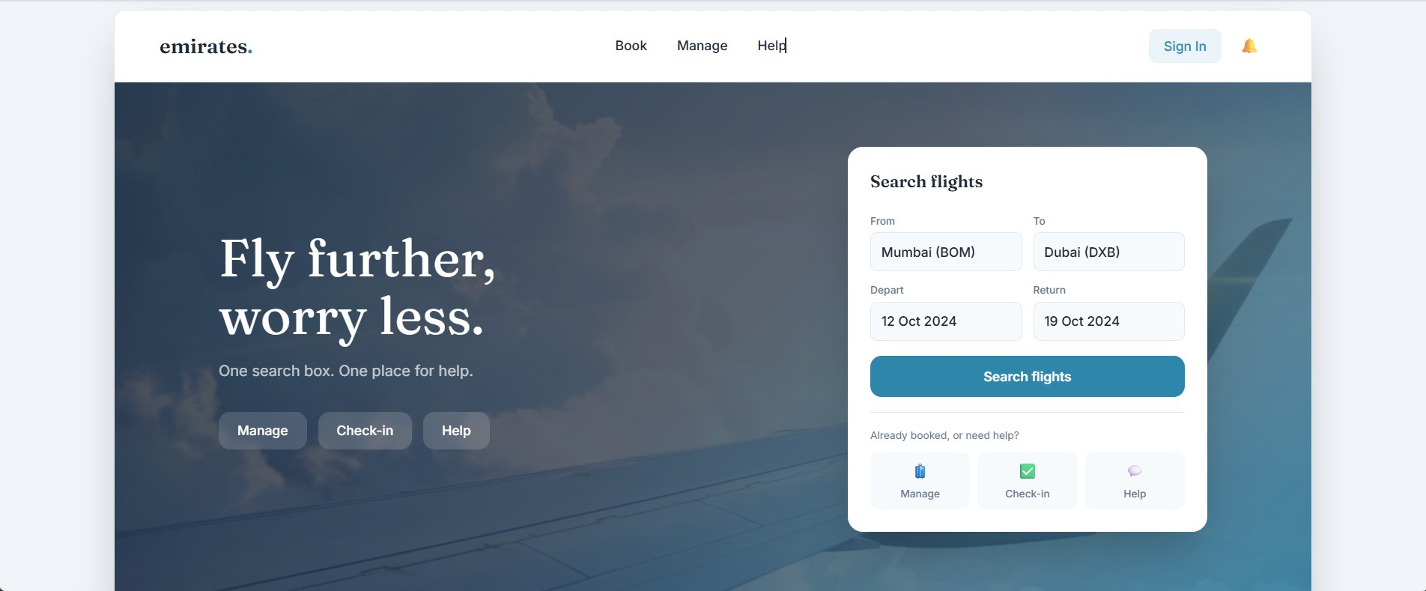
Screen 1: Home
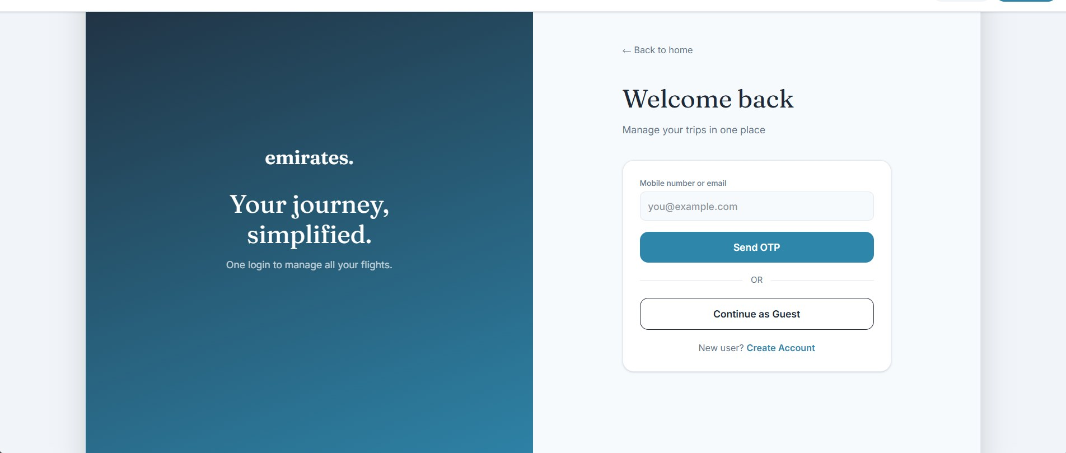
Screen 2: Login / Sign Up
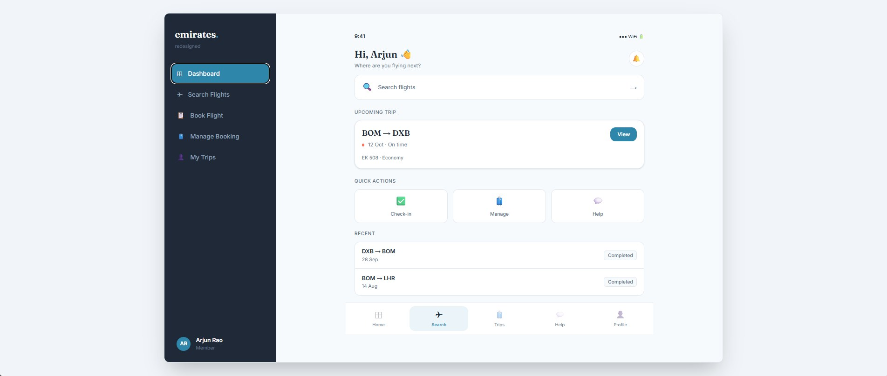
Screen 3: Dashboard
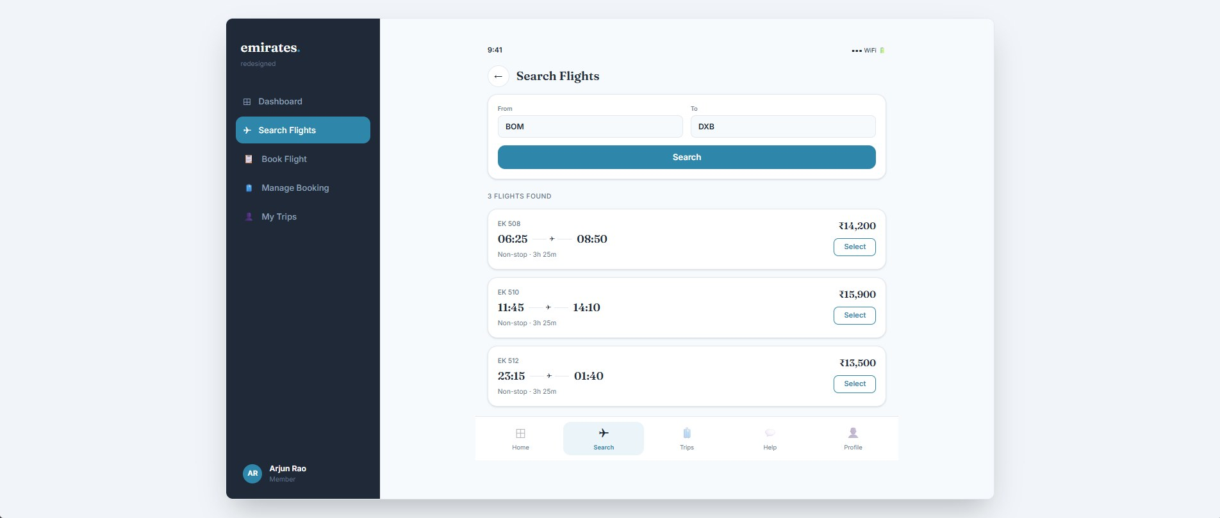
Screen 4: Search Flights
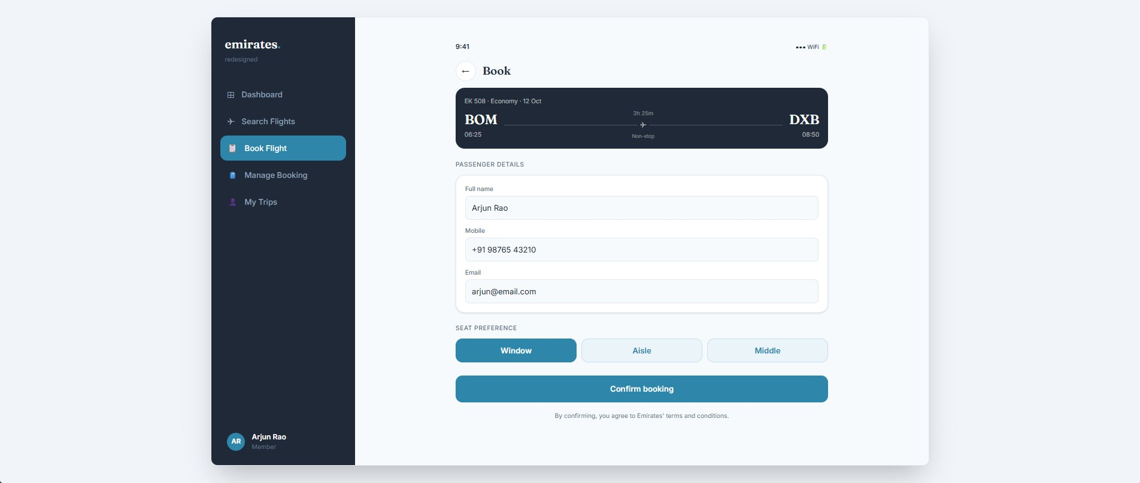
Screen 5: Book Flight
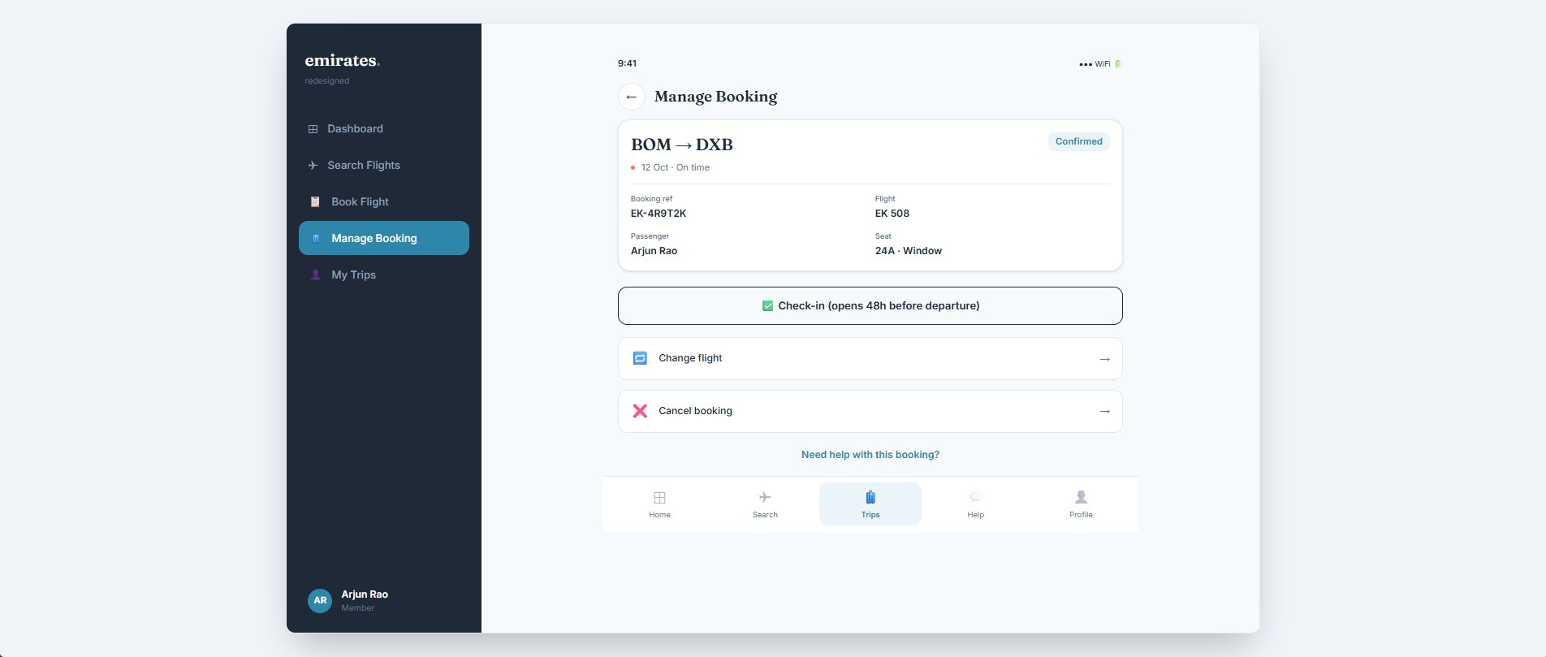
Screen 6: Manage Booking
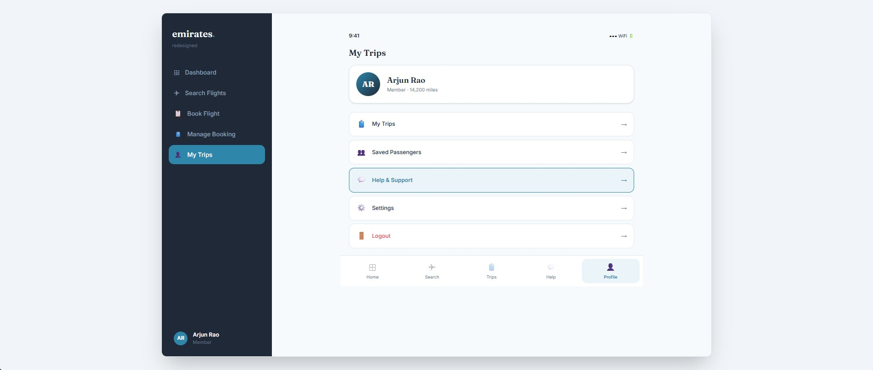
Screen 7: My Trips / Profile
PART II : List out any other points that you may have missed out . (Other than Nielsen’s Principles)

S.NO | OBSERVATIONS | COMMENTS
1 | First-time use | There is no short guide or hint for a new user.
2 | Empty screens | My Trips does not show what a new user sees before any booking.
3 | Colour and reading | Status uses colour plus words, which is good. The small grey text should be checked for contrast.
4 | Waiting time | No loading sign is shown when searching or confirming.

Students Evaluation Team : Group evaluating this system

